**Italy Respiratory Devices Market**

According to Intelli, the Italy respiratory devices market was valued at USD 1,269 million in 2024 and is projected to reach USD 1932.65 million by 2032, growing at a CAGR of 6.30% from 2024 to 2032.

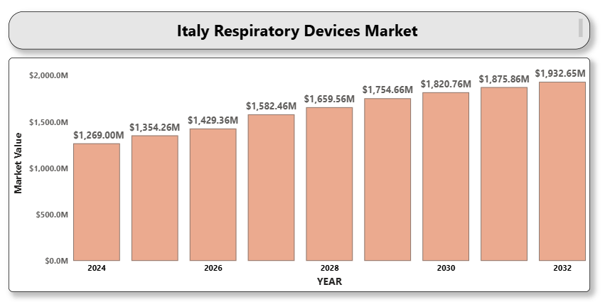

The growth of the market is driven by the increasing prevalence of chronic respiratory diseases such as chronic obstructive pulmonary disease (COPD), asthma, sleep apnea, and respiratory infections. Rising air pollution levels, smoking rates, and the aging population contribute significantly to the growing burden of respiratory illnesses, driving demand for respiratory devices such as ventilators, inhalers, nebulizers, and oxygen concentrators.

Technological advancements, such as the development of portable respiratory devices, smart inhalers, and high-flow oxygen therapy, are improving patient convenience and care, thereby boosting adoption rates. Furthermore, Italy's healthcare infrastructure modernization efforts, combined with rising awareness regarding respiratory health and early disease diagnosis, are creating favorable market conditions.

The COVID-19 pandemic has further accelerated the demand for respiratory devices, highlighting the critical importance of ventilators and oxygen support devices, leading to increased healthcare investments in this sector. As home healthcare and telemedicine solutions expand, the demand for portable and easy-to-use respiratory devices is expected to continue rising.

**Italy Respiratory Devices Market Definition**

Respiratory devices refer to a broad range of medical equipment designed to assist individuals with breathing difficulties, detect respiratory function abnormalities, or support respiratory therapies. These include diagnostic tools (like spirometers and capnographs), therapeutic devices (such as oxygen concentrators, nebulizers, ventilators, and inhalers), and monitoring equipment. Respiratory devices are crucial in managing acute and chronic respiratory diseases, ranging from asthma and COPD to severe infections and respiratory distress syndromes.

The market also encompasses emerging technologies such as AI-enabled smart ventilators, portable oxygen therapy systems, and home-use sleep apnea devices. These innovations are enhancing patient independence, reducing hospital visits, and improving overall healthcare outcomes. In Italy, with an aging demographic and increasing focus on at-home healthcare, respiratory devices are becoming indispensable components of disease management strategies.

**Italy Respiratory Devices Market Overview**

The Italy respiratory devices market is on a growth trajectory fueled by a combination of demographic, environmental, and healthcare system factors. The country's aging population, increasing prevalence of respiratory conditions, and exposure to urban air pollutants are significant demand drivers. Rising public awareness about early diagnosis and management of respiratory disorders is also boosting the adoption of both therapeutic and monitoring respiratory devices.

The Italian government's healthcare initiatives, particularly those focused on non-communicable disease management and home care support, are further supporting market expansion. Technological innovations, such as wearable respiratory devices and telemedicine-based monitoring, are making respiratory healthcare more accessible and personalized. However, high device costs and reimbursement challenges still act as hurdles, particularly for advanced technologies. Overall, the trend towards portable, easy-to-use, and smart respiratory care devices is expected to define the future of the Italian market.

**Italy Respiratory Devices Market Segmentation Analysis**

**Market Segmentation by Product Type**

* **A close-up of hands holding a tablet and a pen

  Description automatically generatedTherapeutic Devices**: Ventilators, oxygen concentrators, CPAP devices, BiPAP devices, nebulizers, and inhalers dominate this segment, addressing a wide range of respiratory conditions.
* **Monitoring Devices**: Devices like pulse oximeters and capnographs are gaining importance in hospitals and home settings to monitor respiratory parameters.
* **Diagnostic Devices**: Spirometers and peak flow meters are essential for the early detection and management of respiratory diseases.
* **Consumables & Accessories**: Masks, cannulas, tubing, filters, and breathing circuits represent a recurring and essential component of respiratory care.

**Market Segmentation by End-User**

* **Hospitals**: Hospitals remain the largest end-user segment due to advanced critical care units and respiratory therapy departments.
* **Home Healthcare**: The demand for home-use devices is expanding, driven by chronic disease management, aging population, and the need for cost-effective healthcare delivery.
* **Ambulatory Surgical Centers (ASCs) and Clinics**: These facilities increasingly use respiratory devices for outpatient care, diagnostics, and day surgeries.

**Market Segmentation by Technology**

* **Invasive Respiratory Devices**: Devices requiring intubation such as mechanical ventilators, used mainly in critical care units.
* **Non-Invasive Respiratory Devices**: Includes CPAP, BiPAP, and portable oxygen systems, favored for both hospital and home-based care due to lower patient risk and easier management.

**Market Segmentation by Application**

* **COPD**: The largest segment, driven by Italy’s high COPD prevalence linked to smoking and air pollution.
* **A close-up of hands holding a tablet and a pen

  Description automatically generatedAsthma**: Inhalers and nebulizers continue to witness high demand due to rising asthma incidences across all age groups.
* **Sleep Apnea**: Rising diagnosis rates are fueling the demand for CPAP and BiPAP devices.
* **Other Applications**: Includes pneumonia, cystic fibrosis, respiratory failure, and pulmonary hypertension treatments.

**Competitive Landscape**

**Key Players in the Italy Respiratory Devices Market:**

* Philips Respironics
* ResMed Inc.
* Medtronic PLC
* Fisher & Paykel Healthcare Corporation Limited
* Drägerwerk AG & Co. KGaA
* Vyaire Medical, Inc.
* Invacare Corporation
* Getinge AB
* Masimo Corporation
* GE Healthcare

These companies are investing heavily in research and development, introducing AI-driven and portable respiratory devices, and expanding their presence through partnerships and acquisitions.

**Key Developments**

* **In September 2024**, Philips Respironics introduced enhanced oxygen concentrators for home use, with a focus on enhanced portability and patient comfort to meet the increasing need for respiratory care solutions in Italy.
* **A close-up of hands holding a tablet and a pen

  Description automatically generatedIn August 2024**, Fisher & Paykel Healthcare launched a new generation of advanced humidifiers across hospitals in Italy. These state-of-the-art devices are specifically designed to optimize oxygen therapy by improving both moisture control and temperature regulation. By delivering precisely humidified oxygen, they help to maintain airway integrity and support lung function, particularly in critical care settings such as intensive care units (ICUs) and emergency departments.

**Market Attractiveness**

The Italy respiratory devices market presents significant investment opportunities, especially in the segments of home-based respiratory therapy devices, wearable respiratory monitors, and AI-integrated smart respiratory solutions.

**Porter’s Five Forces Analysis**

* **Threat of New Entrants**: Moderate. The market is moderately protected by high capital and regulatory barriers.
* **Bargaining Power of Suppliers**: Moderate. Specialized suppliers of device components hold some leverage.
* **Bargaining Power of Buyers**: High. Hospitals and healthcare systems have significant negotiating power.
* **Threat of Substitutes**: Low. Respiratory devices are essential with limited direct alternatives.
* **Competitive Rivalry**: High. Strong competition among key players to innovate and expand market share.

**TABLE OF CONTENTS**

1. **INTRODUCTION OF ITALY RESPIRATORY DEVICES MARKET**
   * 1.1 Overview of the Market
   * 1.2 Scope of Report
   * 1.3 Assumptions
2. **EXECUTIVE SUMMARY**
3. **RESEARCH METHODOLOGY**
   * 3.1 Data Mining
   * 3.2 Validation
   * 3.3 Primary Interviews
   * 3.4 List of Data Sources
4. **ITALY RESPIRATORY DEVICES MARKET OUTLOOK**
   * 4.1 Overview
   * 4.2 Market Dynamics
     + 4.2.1 Drivers
     + 4.2.2 Restraints
     + 4.2.3 Opportunities
     + 4.2.4 Trends
   * 4.3 Porter’s Five Forces Model
   * 4.4 Value Chain Analysis
5. **ITALY RESPIRATORY DEVICES MARKET, BY PRODUCT TYPE**
   * 5.1 Therapeutic Devices
   * 5.2 Monitoring Devices
   * 5.3 Diagnostic Devices
   * 5.4 Consumables & Accessories
6. **ITALY RESPIRATORY DEVICES MARKET, BY END USER**
   * 6.1 Hospitals
   * A close-up of hands holding a tablet and a pen

     Description automatically generated6.2 Home Healthcare
   * 6.3 Ambulatory Surgical Centers (ASCs) and Clinics
7. **ITALY RESPIRATORY DEVICES MARKET, BY TECHNOLOGY**
   * A close-up of hands holding a tablet and a pen

     Description automatically generated7.1 Invasive Devices
   * 7.2 Non-Invasive Devices
8. **ITALY RESPIRATORY DEVICES MARKET, BY APPLICATION**
   * 8.1 COPD
   * 8.2 Asthma
   * 8.3 Sleep Apnea
   * 8.4 Other Applications
9. **ITALY RESPIRATORY DEVICES MARKET COMPETITIVE LANDSCAPE**
   * 9.1 Overview
   * 9.2 Company Market Ranking
   * 9.3 Key Development Strategies
10. **COMPANY PROFILES**

• **10.1 Philips Respironics**

* 10.1.1 Overview
* 10.1.2 Financial Performance
* 10.1.3 Product Outlook
* 10.1.4 Key Developments

• **10.2 ResMed Inc.**

* 10.2.1 Overview
* 10.2.2 Financial Performance
* 10.2.3 Product Outlook
* 10.2.4 Key Developments

• **10.3 Medtronic PLC**

* 10.3.1 Overview
* 10.3.2 Financial Performance
* 10.3.3 Product Outlook
* 10.3.4 Key Developments

• **10.4 Fisher & Paykel Healthcare Corporation Limited**

* 10.4.1 Overview
* 10.4.2 Financial Performance
* 10.4.3 Product Outlook
* 10.4.4 Key Developments

• **10.5 Drägerwerk AG & Co. KGaA**

* 10.5.1 Overview
* 10.5.2 Financial Performance
* 10.5.3 Product Outlook
* 10.5.4 Key Developments

• **10.6 Vyaire Medical, Inc.**

* 10.6.1 Overview
* 10.6.2 Financial Performance
* 10.6.3 Product Outlook
* 10.6.4 Key Developments

• **10.7 Invacare Corporation**

* 10.7.1 Overview
* 10.7.2 Financial Performance
* 10.7.3 Product Outlook
* 10.7.4 Key Developments

• **10.8 Getinge AB**

* 10.8.1 Overview
* 10.8.2 Financial Performance
* 10.8.3 Product Outlook
* 10.8.4 Key Developments

• **10.9 Masimo Corporation**

* 10.9.1 Overview
* 10.9.2 Financial Performance
* 10.9.3 Product Outlook
* 10.9.4 Key Developments

• **10.10 GE Healthcare**

* 10.10.1 Overview
* 10.10.2 Financial Performance
* 10.10.3 Product Outlook
* 10.10.4 Key Developments

1. **KEY DEVELOPMENTS**
   * 11.1 Product Launches/Developments
   * 11.2 Mergers and Acquisitions
   * 11.3 Business Expansion
2. **APPENDIX**
   * Related Research

